**Project Report**

**On**

**Face Mask Detection**

**to be developed to fulfill the requirements for**

**Major Project (CA133)**

**Submitted to**

**Department of Computer Applications**

**Chitkara University, Punjab**



**under the supervision of**

**Dr. Amandeep Bhullar**

**Submitted by**

Yatin Bajaj Abhinav Sharma

1810992625 1810992633

**Bachelor of Computer Applications**

**(Batch 2018-21)**

**Table Of Contents**

1. Abstract of the project.
2. Profile of problems assigned.
3. Study of existing system.
4. System requirements
   1. Product Definition
      1. Problem Statement
      2. Function to be provided
      3. Processing Environment: H/W, S/W.
      4. Solution Strategy
   2. Project Plan
      1. Team Structure
      2. Development Schedule
      3. Programming Languages And Development Tools
5. System Requirement Specifications
   1. Developing / Operating / Maintenance Environments
   2. External Interface and Datat Flows
   3. Functional and Performance Specifications.
6. Design
7. Project Legacy
   1. Current status of project
   2. Technical and managerial lessons learnt
   3. Future recommendations
8. References

### Abstract

COVID-19 pandemic caused by novel coronavirus is continuously spreading until now all over the world. The impact of COVID-19 has been fallen on almost all sectors of development. The healthcare system is going through a crisis. Many precautionary measures have been taken to reduce the spread of this disease where wearing a mask is one of them. In this project, we propose a system that restrict the growth of COVID-19 by finding out people who are not wearing any facial mask in a smart city network. A deep learning architecture is trained on a dataset that consists of images of people with and without masks collected from various sources. The trained architecture achieved 98.7% accuracy on distinguishing people with and without a facial mask for previously unseen test data. It is hoped that our study would be a useful tool to reduce the spread of this communicable disease for many countries in the world.

### Profile of problems assigned

The year 2020 has shown mankind some mind-boggling series of events amongst which the COVID-19 pandemic is the most life-changing event which has startled the world since the year began. Effecting the health and lives of masses, COVID-19 has called for strict measures to be followed in order to prevent the spread of disease. From the very basic hygiene standards to the treatments in the hospitals, people are doing all they can for their own and the society’s safety; face masks are one of the personal protective equipment. People wear face masks once they step out of their homes and authorities strictly ensure that people are wearing face masks while they are in groups and public places.

To monitor that people are following this basic safety principle, a strategy should be developed. A face mask detector system can be implemented to check the safety guidelines. Face mask detection means to identify whether a person is wearing a mask or not. The ﬁrst step to recognize the presence of a mask on the face is to detect the face, which makes the strategy divided into two parts: to detect faces and to detect masks on those faces. Face detection is one of the applications of object detection and can be used in many areas like security, bio-metrics, law enforcement and more. There are many detector systems developed around the world and being implemented. However, all this science needs optimization; a better, more precise detector, because the world cannot afford any more increase in corona cases.

1. Study of existing system

A face mask detection is a technique to find out whether someone is wearing a mask or not. It is similar to detect any object from a scene. Many systems have been introduced for object detection. Deep learning techniques are highly used in medical applications. Recently, deep learning architectures have shown a remarkable role in object detection. These architectures can be incorporated in detecting the mask on a face.

1. System requirements

**a.** Product Definition

**a)** Problem Statement

As the virus outbreak continues, business leaders are coming up with innovative digital solutions. One of them is a face mask detection system to identify people with face masks.

**b)** Function to be provided

Functions provided by the project are image processing, creating architecture, and training model.

Load model and classify the images using image classifier. Show result weather a person is wearing mask or not.

**c)** Processing Environment: H/W, S/W.

|  |  |  |
| --- | --- | --- |
| **Hardware Requirements:** | **Minimum** | **Recommended** |
| **Processor** | Intel i3-6100 @ 1.7GHz or  AMD Athlon X4 770K @2GHz. | Intel i5-4400 @2.30GHz. |
| **Operating system** | Windows 8 - 64-Bit | Windows 10 – 64-Bit |
| **Memory** | 4GB RAM. | 8GB RAM. |
| **Hard disk space** | 1GB available space. | 2.5GB available space. |

**d)** Solution Strategy

As per the problem statement, the goal had been achieved successfully. OpenCV package is used to read an image and perform certain image processing techniques. TensorFlow is used to implement deep neural networks and to train the model for the project with some learning rate set by user.

**e)** Acceptance Criteria

The webcam provides with a video stream, our AI trained model further processes the data and the trained model extracts the features and differentiate if the person has worn a mask or not.

If the person is not wearing mask their image is captured and is forwarded to the respected person via E-mail.

#### b. Project Plan

#### a) Team Structure

1. Abhinav: Research and Collection of Dataset.

2. Yatin: Image Processing and Training of model.

#### b) Development Schedule

|  |  |  |  |
| --- | --- | --- | --- |
|  | **1 Dec - 12 Dec**  **2020** | **14 Dec – 26 Dec**  **2020** | **29 Dec – 8 Jan**  **2020** |
| **Synopsis Submission** |  |  |  |
| **Implementation** |  |  |  |
| **Report Writing** |  |  |  |
| **Final submission** |  |  |  |

#### c) Programming Languages And Development Tools

In this project OpenCV is used to do real-time face detection from a live stream via camera. We used the dataset to build a COVID-19 face mask detector with computer vision using Python, OpenCV, and Tensor Flow Framework and Keras API.

### System Requirement Specifications

#### a. Developing / Operating / Maintenance Environments

1. Windows Operating System.

2. Software used Pycharm / VisualStudio.

3.Memory Required 4GbRAM

#### b. External Interface And Data Flows

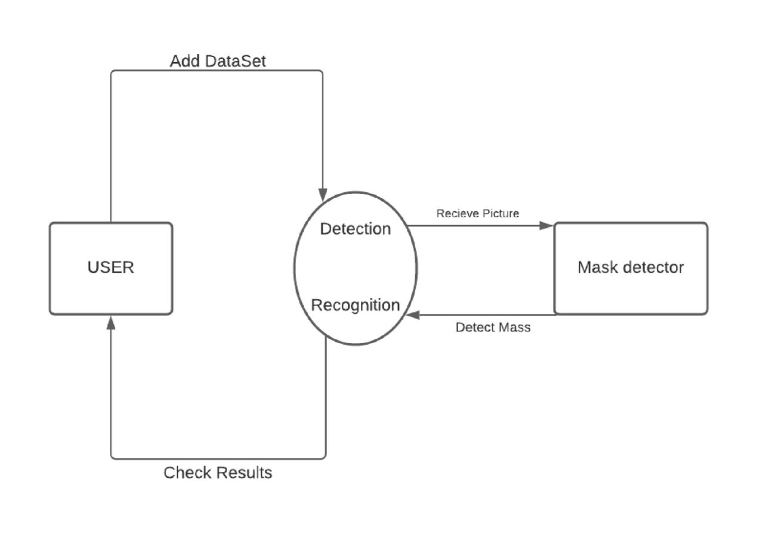

#### c. Functional and performance specifications

* Functional Requirements:

1. System can detect face of people.
2. The system must be attached to the webcam and face recognition should be smooth.

* Performance Requirements:

Minimum Requirements: i3-8th gen, 4gb RAM, 1gb HDD, python 3.6 and above and some python-based libraries.

Recommended Requirements: i5-4th gen, 8gb RAM, 1gb HDD, python 3.6 and above and some python-based libraries.

1. Design

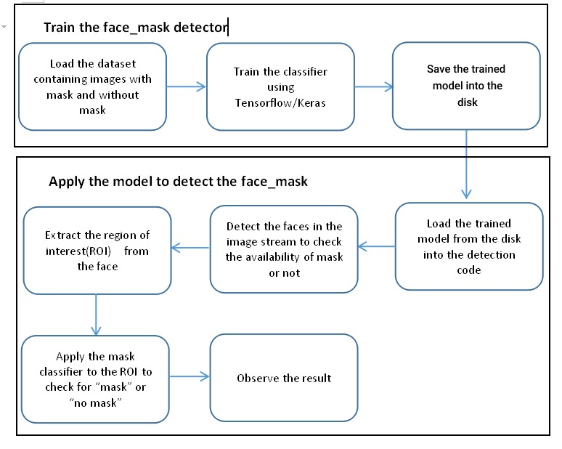

1. **Data structures, database and file specifications**

Presently This project is a module for now, which is based on a local database management system, i.e. we need to give the path of the data set from our system to train the model. This project can afterwards be embedded with any desktop application and mobile application. Also, this project can work well with web-based applications. This project can be put into use with CCTV cameras with the help of RTSP(Real Time Streaming Protocol) URL’s, so that it can function for Face Mask Detection in Public Area's.

### Project Legacy

#### a. Current status of project

The project is able to determine whether a person is wearing a face mask or not with an accuracy of 95-100% (aaprox).As of now the project is based on temporary dataset and the field of uses are malls, office, colleges etc.The stalling point of the project can be accessories such as sunglasses, hats etc. Can negatively impact the accuracy of model to detect.

#### b. Technical and managerial lessons learnt

We have acquired knowledge about how to do image processing, creating and training the deep learning model. Also, while making the project, we learn how to manage team.

[https://www.geeksforgeeks.org/software-requirement-specification-srs-forma t/](https://www.geeksforgeeks.org/software-requirement-specification-srs-forma%09t/)

<https://www.mygreatlearning.com/blog/real-time-face-detection/>

[https://towardsdatascience.com/why-data-should-be-normalized-before-traini ng-a-neural-network-c626b7f66c7d](https://towardsdatascience.com/why-data-should-be-normalized-before-traini%09ng-a-neural-network-c626b7f66c7d)

c. Future recommendations

In future this project can very well be attached to an Arduino based system that supports an infrared temperature monitoring sensor.

### References (IEEE)

1. Benjamin Bergner, Prof. Dr. Christoph Lippert, Raza Akiachak Ahmed,Saniya Adeel, facemask detector, July 2020 DOI: 10.13140/RG.2.2.32147.50725 Affiliation: Universität Potsdam

“Artificial Intelligence”.

Available: <https://www.researchgate.net/publication/344173985_Face_Mask_Detector>

1. Vinitha.V1, Valentina, "COVID-19 FACEMASK DETECTION WITH DEEP LEARNING AND COMPUTER VISION", Volume: 07 Issue: 08 | Aug 2020 "Student, Department of Master of Computer Application, AMC Engineering College Bangalore, Karnataka, India ".

Available: <https://www.irjet.net/archives/V7/i8/IRJET-V7I8530.pdf>

1. Feng S., Shen C., Xia N., Song W., Fan M., Cowling B.J. Rational use of face masks in the COVID-19 pandemic. Lancet Respirate. Med. 2020;8(5):434–436. doi:10.1016/S2213- 2600(20)30134-X.
2. Sandler, Mark, Andrew Howard, Meng long Zhu, Andrey Zymogene, and Liang-Chieh Chen, "Mobilenetv2: Inverted residues and linear bottlenecks," IEEE Conference on Computer Vision and Pattern Recognition, pp. 4510-4520. 2018.
3. S. Feng, C. Shen, N. Xia, W. Song, M. Fan, and B. J. Cowling, “Rational use of face masks in the covid19pandemic,”The Lancet Respiratory Medicine, 2020.